**NAME: KHAIRULLAH KHALIQ COURSE: CS-212(HCI)**

**REGISTRATION NO: 04072113003 BATCH: BSCS (3rd semester)**

**“ASSIGNMENT (1)”**

**ANALYSE ANY DAILY LIFE PRODUCT BASED ON A GIVEN PRINCIP**

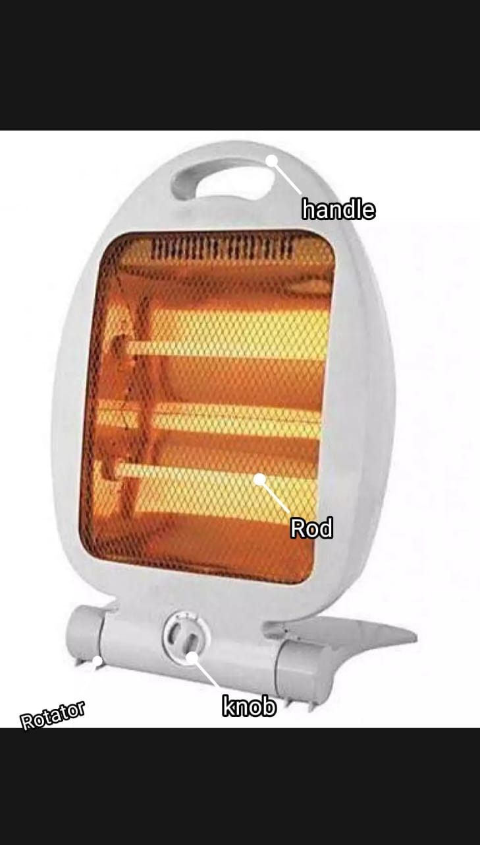

**PRODUCT NAME:** **“ELECTRIC HEATER “**

 An Electric heater is designed to provide instant heat and heat the room instantly. They come with safety grills and most models have variable temperature settings. It is fully portable and can be moved from place to place with minimal disruption.

**1. VISIBILITY OF THE PRODUCT:**

The controlling parts and parts being controlled are visible and distinct. Therefore, the overall visibility of the product is quite easy to see and use the product efficiently. The visibility of this product, and the inspected parts must be distinct. If the correct parts are visible, the user will have a clear message about the operation of the product.

**a) CONTROLLING PARTS:**

 The controlling parts of this Electric heater are:

**1. Knob:**

 There is a knob on the electric heater to on or off and increase or decrease the speed of heat. The visibility is perfect on this product.

**2. Carry Handle:**

 There is a handle on the top of the product with which we can move the product from place to place. being on the top the handle is perfectly visible to the user.

**3. Rotator:**

There is a rotator in the bottom part of this product to rotate the internal rods of the heater up and down in the order to direct the flow of heat.

**b) PARTS BEING CONTROLLED:**

**Rods:**

The visibility of these Rods is enough for the user to see whether the heater is on or off. We cannot touch it which element the chances of danger in that situation.

**2. FEEDBACK:**

There is a twin rod inside the heater. When we use this product for heating, the rods light up like a light bulb, indicating that our device is on.

**3.SIGNIFIERS:**

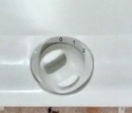There is a knob on the electric heater to **on** or **off** and to increase or decrease the speed of the heater, we can classify it as a signifier. For the signifiers, the knob is a small circle shape that has mathematically labeled there ‘0’ as ***off***, ‘1’ as ***on*** with a single rod, and ‘2’ as ***on*** with a double rod. So, the users will think that label ‘0’ is off and label ‘1 or’2’ is on while they use the electric heater.

**4. AFFORDANCE:**

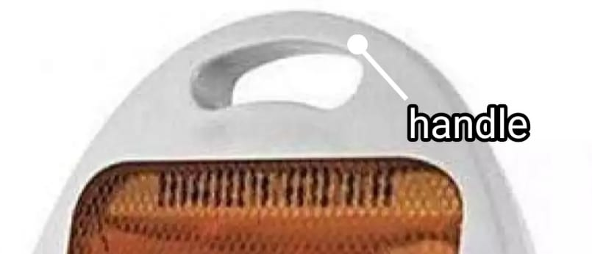Turn the knob on or off, then increase or decrease the heat speed. We can define it as an affordance since the on/off knob has a small circular shape that allows the user's finger to spin at different angles. The handle of the electric heater, as seen in the image below, is an affordance. The curved form of the handle accommodates user fingers as they grip this device.

**5.MAPPING:**

In this product, the knob uses (one to many) (1*3) mapping as shown above picture. When you use this product, you spin the knob with different angels.

**6.CONCEPTUAL MODEL:**

**a) designer model:**

The designer's concept for this product is to spin the knob to rotate the rod inside the heater up and down, directing the flow of heat.

**b) user model (system image):**

The user may know how to use the knob and he/she spin the knob and rotate the heater and have no difficulty operating it. It is according to the designer's model. So, in this case, the design cannot create any difficulties for the user to operate.

***“THE DESIGNER MODEL AND USER MODEL, CANNOT DIFFERS IN THIS CASE”***